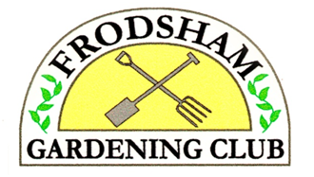
48 Clifton Road,
Runcorn,
Cheshire,
WA7 4SZ
15th March 2026
Tel: 01928 565600

Dear Gardener,

Visit to Southport Flower Show
on Thursday, 20th August 2026 from 9:30am to about 4:00pm

We plan to leave Frodsham Community Centre at 9.30am and travel by Anthony’s coach to the Flower Show at Southport, arriving at about 10:30am, depending on the traffic.

Southport Flower Show was first held in 1924 and has been held every year since then, apart from during the two world wars. Since 1986 the Show has been managed by a charity and is the UK’s largest independent flower show. It is held in Victoria Park, Southport.

The 2026 event features spectacular show gardens, a grand flora marquee, celebrity guests, (Adam Frost and Arit Anderson have been confirmed), cookery demos and family entertainment. The show hosts over 300 trade exhibitors, a food festival and arena performances.

We will leave Southport at about 3:00pm, arriving at Frodsham Community Centre at about 4:00pm.

The cost of this trip is £35 for members and non-members. This covers coach transport to Southport and entry to the show. No food or drink is included. There will be a variety of dining options available, including: a vintage tea room, a brasserie, street food, etc.

If you would like to join us please complete the form below and bring it, together with your payment, to the next meeting or send your form and cheque (made payable to Frodsham Gardening Club) to the above address. It is also possible to pay by bank transfer (Business Account: Sort code 01 09 17, A/c No 66357772). Tickets for the Show will be handed out on the coach.

Kind regards,
Gwyn

VISIT to SOUTHPORT FLOWER SHOW
on Thursday, 18th 20th August 2026, 9:30am to about 4:00pm

Member’s Name : _________________________________________________

Contact Telephone Number: ___________________________

Visitor’s Name: ___________________________________________________

Amount Paid: ___________________ (cash / cheque / bank transfer)

